**Azure zero to hero**

Basics concept of azure:

What is cloud:

The cloud" refers to servers that are accessed over the Internet, and the software and databases that run on those servers. Cloud servers are located in data centers all over the world.

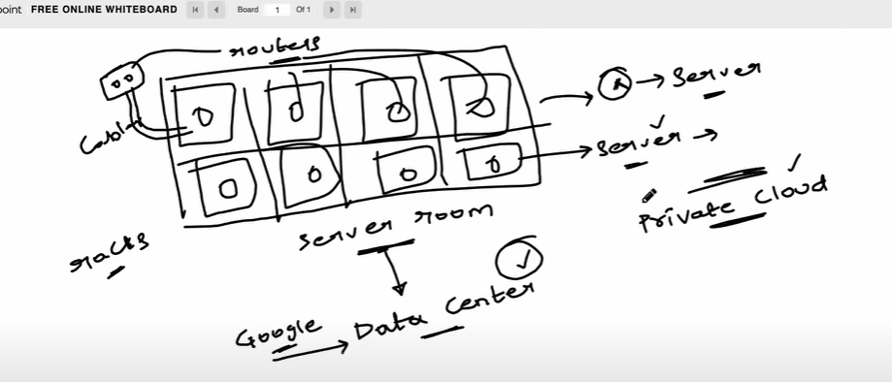

Private vs public cloud

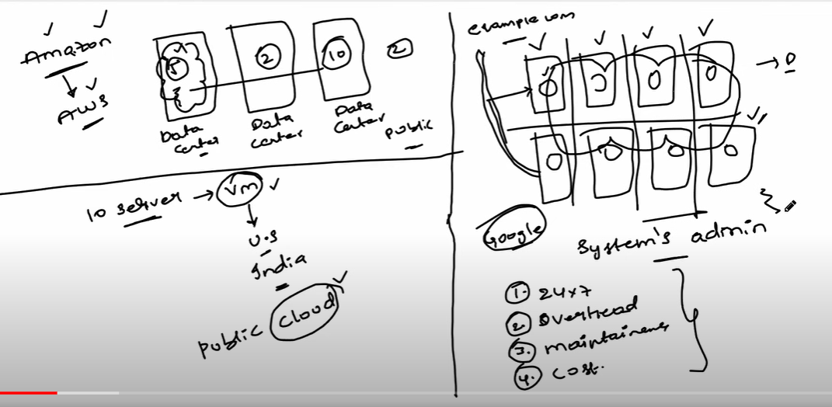

Hybrid cloud

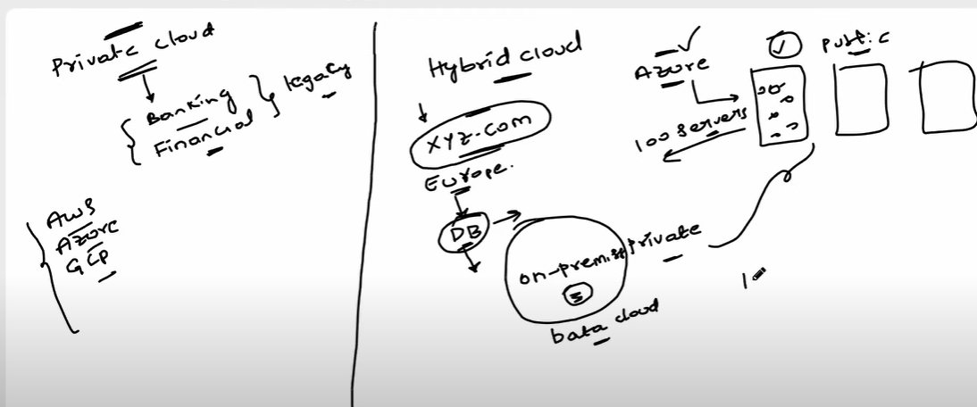

Cloud computing- if you are running your application on cloud is called cloud computing

Cloud computing is the delivery of different services through the Internet, including data storage, servers, databases, networking, and software. Cloud storage has grown increasingly popular among individuals who need larger storage space and for businesses seeking an efficient off-site data back-up solution.

Virtualization:

Virtualization is the process of creating a virtual version of something, such as an operating system, server, storage, or network resources.

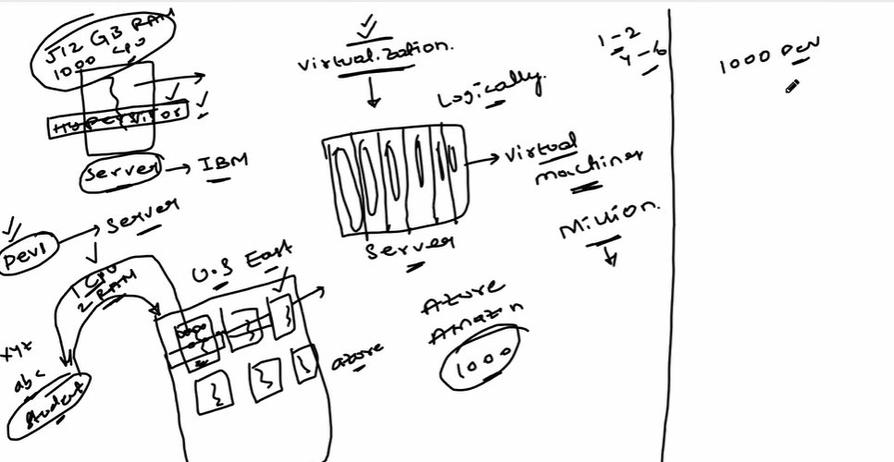

**Virtual Machine**

A Virtual Machine (VM) is a software-based emulation of a physical computer. It allows running multiple operating systems on a single physical machine.

API:

API is a set of rules and protocols that allows different software applications to communicate with each other. It defines how software components should interact.

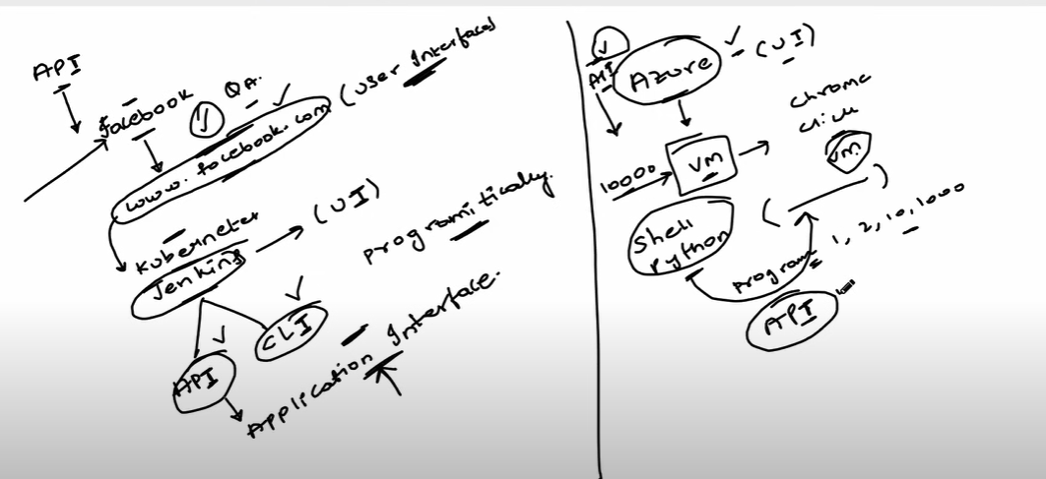

Regions:

Regions in cloud computing refer to geographic locations where cloud providers have data centers. Each region contains multiple data centers.

Availability Zones :

They are isolated locations within a region that have their own power, cooling, and networking. They are designed to provide high availability and fault tolerance.

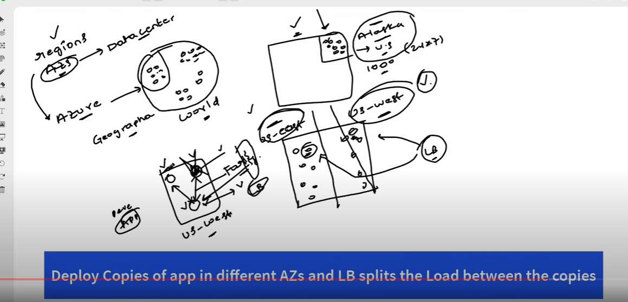

## Load Balancing

Load Balancing is the distribution of network traffic or computing workload across multiple servers to ensure no single server is overwhelmed.

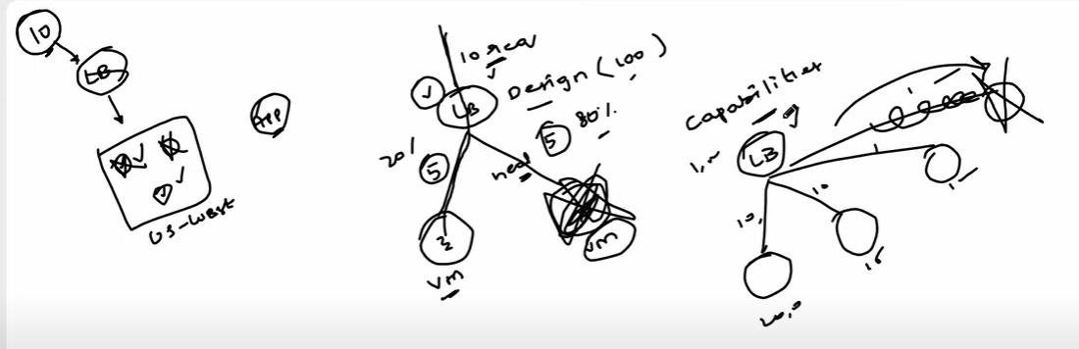

## Scalability

Scalability is the ability of a system to handle an increasing amount of work or its potential to be enlarged to accommodate that growth.

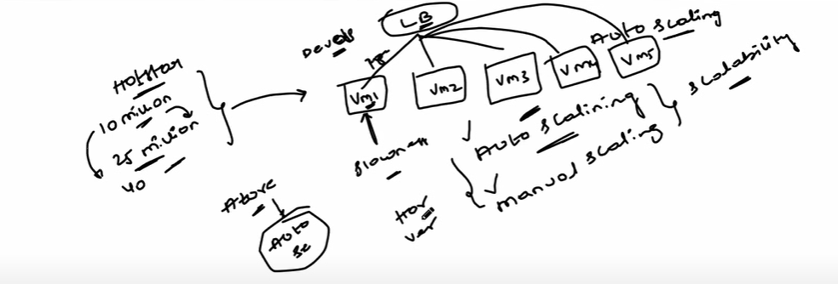

## Elasticity

Elasticity in cloud computing refers to the ability to dynamically scale resources up or down based on demand.

## High Availability

High Availability (HA) ensures that a system or application is operational and accessible for a high percentage of time, typically 99.9% or higher.

## Disaster Recovery

Disaster Recovery involves the planning and processes for restoring and recovering data and systems after a natural or human-induced disaster.

## Fault Tolerance

Fault Tolerance is the ability of a system to continue operating without interruption in the presence of hardware or software failures.